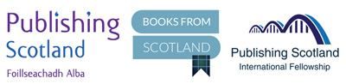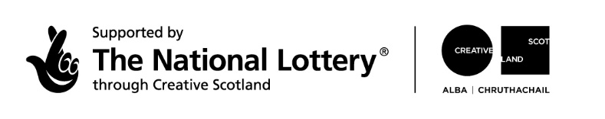

PRESS RELEASE
STRICTLY EMBARGOED UNTIL MONDAY 4 APRIL 2022

PUBLISHING SCOTLAND REVEALS 2022 INTERNATIONAL PUBLISHING FELLOWS

Publishing Scotland has announced its new International Publishing Fellows for 2022. The Fellows were chosen for the scheme in 2020 and were keen to keep their spaces live and current for when the international book trade opened up again.

Marion Sinclair, CEO of Publishing Scotland, revealed the 9 publishers who have been chosen for the sixth International Fellowship which marks 54 publishers who have visited the country to meet Scottish publishers and experience the culture and landscape.

- Dr. Cordelia Borchardt, S. Fischer Verlage, Germany
- Sarah Cantin, St. Martin's Press, USA
- Nicolás Rodríguez Galvis, Éditions Métailié, France
- Esther Hendriks, De Arbeiderspers/Singel Publishers, The Netherlands
- Peter Joseph, Harper Collins, USA
- Talia Marcos, Keter Books, Israel
- Jean Mattern, Editions Grasset & Fasquelle, France
- Andrea Stratilová, Albatros media, Czechia
- Mark Tauber, The Watermark Agency, formerly of Chronicle Books, USA

The group will spend a week in Scotland at the end of August meeting Scotland-based publishers, agents and writers in a varied programme of events across the country including the Edinburgh International Book Festival, dinner at Robert Louis Stevenson’s former home, a writer showcase in Glasgow and a trip to the Highlands to meet publishers and writers there.

The purpose of the visit is to help develop relationships between the international publishing community and the Scottish sector, facilitate rights selling and bring Scottish books to an international audience. Previous fellows have acted as advocates for the Scottish publishing scene and the Publishing Scotland drinks receptions at the Frankfurt and London Book Fairs is now a hive of international activity as Fellows reconnect with the publishers.

Scotland-based literary agent Jenny Brown of Jenny Brown Associates, who has been involved with the Fellowship since it was established in 2014, said: “The Fellowship enables us to meet publishers and understand their markets, introduce them to authors and for them to encounter the vibrant literary scene here, in a way that brief 30-minute meetings at book fairs can never achieve. And it works in terms of selling rights, we’ve struck many international deals with Fellows past and present, for Scottish writers.”

Marion Sinclair, Chief Executive of Publishing Scotland, said: “We are hugely privileged to have this Fellowship Programme as a means of attracting people to come and experience the industry here. Thanks to our funders, in the six years since the Fellowship began, we will have invited 55 senior international publishers to Scotland and given our publishers, agents, and writers the chance to get to know them in a more relaxed setting. It’s all part of a wider internationalisation strand within our work and is paying dividends in terms of rights deals made, and in the very important relationships that have been forged between the Fellows and the sector.”

The award-winning programme from the network, trade and development body for the book publishing sector in Scotland is supported by funding from Creative Scotland.

Alan Bett, Head of Literature and Publishing, Creative Scotland, said: “The International Publishing Fellowship builds relationships between publishers and therefore develops channels for voices in Scottish literature to reach readers beyond the UK. By facilitating rights sales in international territories, the programme builds a more global readership and profile for our authors, as well as contributing towards sustainable writing careers.”

ENDS

Notes to Editors
- The 2015 Fellowship week was shortlisted in the Best Networking Event category at the Association Excellence Awards UK

Publishing Scotland is the network for trade, training and development. We're a membership body and a charity. The International Fellowship Programme is part of our internationalisation work, along with the Translation Fund, rights catalogues, Go-See Fund, and Bookfair representation, which are all designed to make doing business overseas easier and more cost-effective for publishers.
Visit the website: www.publishingscotland.org
Follow on Twitter: @publishscotland

About Creative Scotland: Creative Scotland is the public body that supports the arts, screen and creative industries across all parts of Scotland on behalf of everyone who lives, works or visits here. We enable people and organisations to work in and experience the arts, screen and creative industries in Scotland by helping others to develop great ideas and bring them to life. We distribute funding provided by the Scottish Government and the National Lottery.
Visit the website: www.creativescotland.com

Follow Creative Scotland
Twitter: https://twitter.com/CreativeScots
Facebook: www.facebook.com/CreativeScotland
Instagram: www.instagram.com/creativescots

For more info, please contact Publishing Scotland – enquiries@publishingscotland.org

Publishing Scotland
Scott House
10 South St Andrew Street
Edinburgh
EH2 2AZ

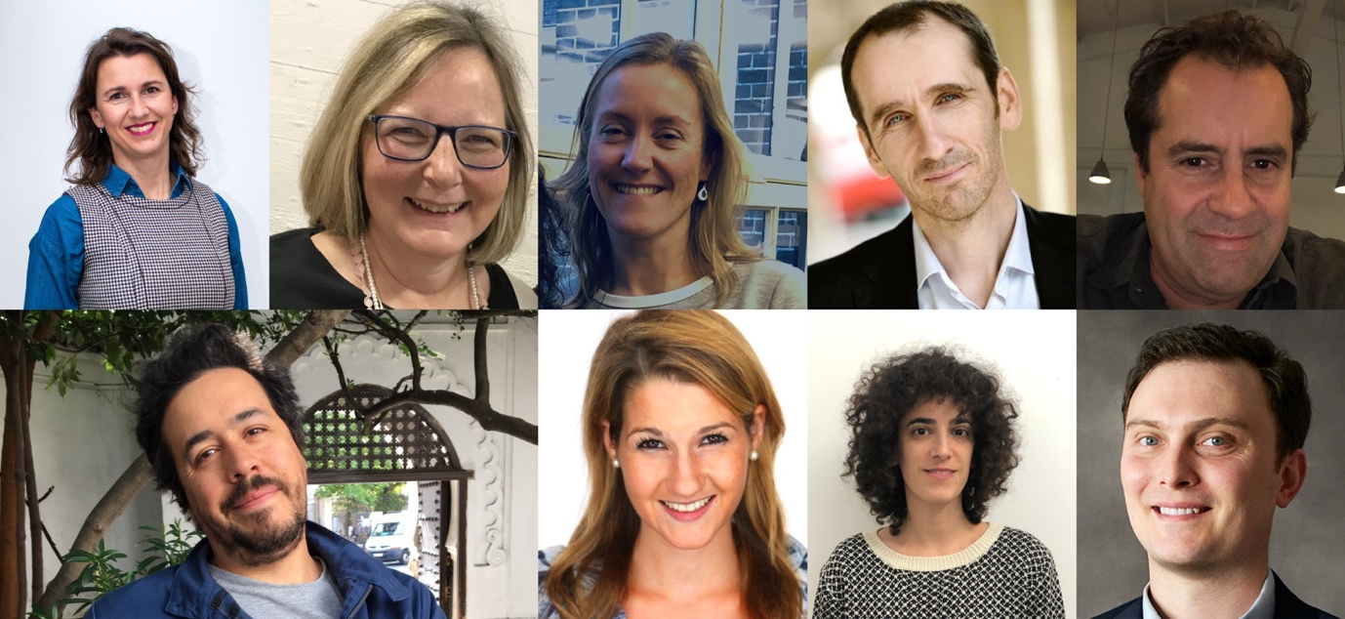

Photo: top row from left to right:
- Andrea Stratilová, Albatros media, Czechia
- Dr. Cordelia Borchardt, S. Fischer Verlage, Germany
- Esther Hendriks, De Arbeiderspers/Singel Publishers, The Netherlands
- Jean Mattern, Editions Grasset & Fasquelle, France
- Mark Tauber, Chronicle Prism, an imprint of Chronicle Books, USA

Photo: bottom row from left to right
- Nicolás Rodríguez Galvis, Éditions Métailié, France
- Sarah Cantin, St. Martin's Press, USA
- Talia Marcos, Keter Books, Israel
- Peter Joseph, Harper Collins, USA

